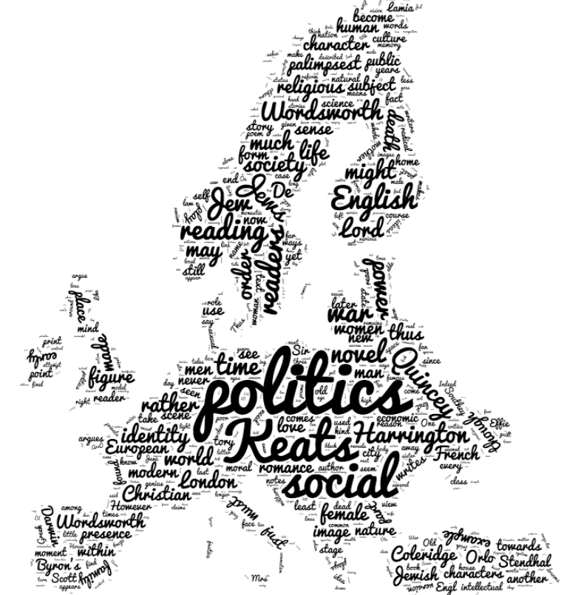
Authors of Focus:
- John Keats
- Lord Byron
- John Clare
- William Godwin
- William Wordsworth

*The following authors had entire issues devoted to them alone: John Keats, Robert Southey, John Thelwall, and Thomas De Quincey

Major Themes:

- Consumption: as self reflection, as
represented by the literary market,
author-to-author, networking,
fandom

- The imagination and irrationality:
reception and integration of

- Overlooked peripheral influences
on writers: politicians/politicians,
scientists, theorists, etc.

Popular Critical Lenses:
- New Historicism

- Psychoanalysis

- Deconstruction
Selected Quotes:

“I think the most intriguing move in current scholarship emanates from the triangulation of literature, philosophy (increasingly political philosophy) and psychoanalysis. The least developed point of this triad is the pleasure of literature, which has to be rescued from the thematic doldrums of ego's blah blah and discovered concretely through deep rereading.”
-from an interview with David Wagenknecht , editor of Studies in Romanticism, for the 50th anniversary issue

“Romanticism . . . marks the moment at which one particular event in the history of mediation – the Enlightenment – reached a point of saturation after which it was both easier and more profitable to write about writing than it was to write about anything else. As a result, the Romantic must be conceived as the period when the Enlightenment event became a metaphor or simulacrum of itself, not an end of Enlightenment but rather, to borrow a term from Jay David Bolter and Richard Grusin, its remediation.”
-from the introduction to the “Romantic Mediations” issue of European Romantic Review

Selected Book Titles:

Romantic Fiat: Demystification and Enchantment in Lyric Poetry | Transgressive Theatricality, Romanticism, and Mary Wollstonecraft | Coleridge and Daemonic Imagination | The Romantic Revolution: A History | Romantic Sobriety: Sensation, Revolution, Commodification, History |

