Slide 1:

My name is Hannah Byers and today I will be discussing poisoning prevention. As students we are essential to improving the health of the population and preventing both intentional and unintentional injuries across all populations.

Slide 2:

Poisoning can occur from any form of substance or materials that if consumed in some way in too large of an amount can result in injury or death (Centers for Disease Control and Prevention, 2015). Poisonings can results in both intentional and unintentional injuries. Below are the substances and areas emphasized by the CDC and the American Association of Poison Control Centers in efforts to prevent poisonings (Centers for Disease Control and Prevention, 2015) (American Association of Poison Control Centers, 2018). These areas reflect the most prevalent substances resulting in poisoning, locations poisonings occur, and populations most likely to suffer from poisonings. The main websites is listed below

https://www.cdc.gov/homeandrecreationalsafety/poisoning/preventiontips.htm

https://aapcc.org/Prevention

The image included on this slide provides an example numerous medications and candy that can be easily mistaken by a child, adult, and older adults resulting in potential poisoning.

Slide 3:

As we see so far a large majority of prevention efforts are focused on unintentional injuries rather than intentional. As of 2016 there were 68,995 fatalities from poisonings across all age groups within a population of the United States, while 84.5% of the total were from unintentional poisonings (Centers for Disease Control and Prevention, 2017). This is equivalent to the death of all individuals in UGA’s Bogg Hall filled to capacity every day of 2016. Stegeman Coliseum at full capacity can hold 10,523 individuals, and 58,335 unintentional poisoning fatalities divided by 10,523 equals 5.544. Bogg Hall has a capacity of 160, and 58,335 unintentional fatalities divided by 365 (days in a year) equals 159.82 therefore equating to the death of individuals if Bogg Hall was full each day. Fatality rates are nearly two times higher among males compared to females for both intentional and unintentional injuries (Centers for Disease Control and Prevention, 2017).

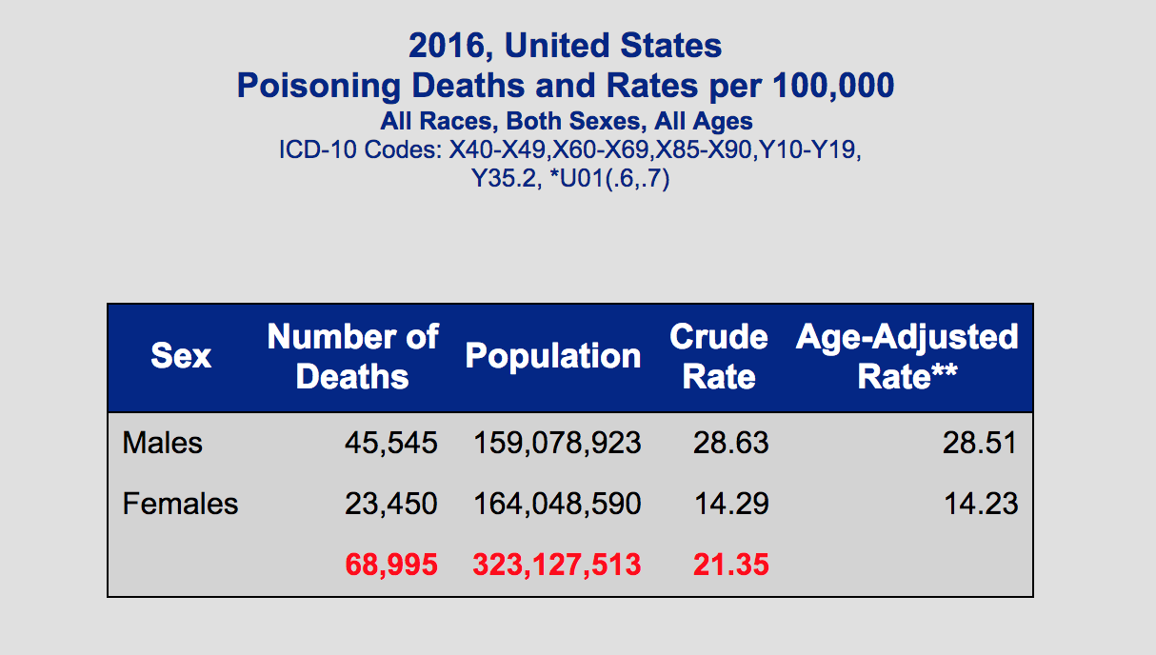
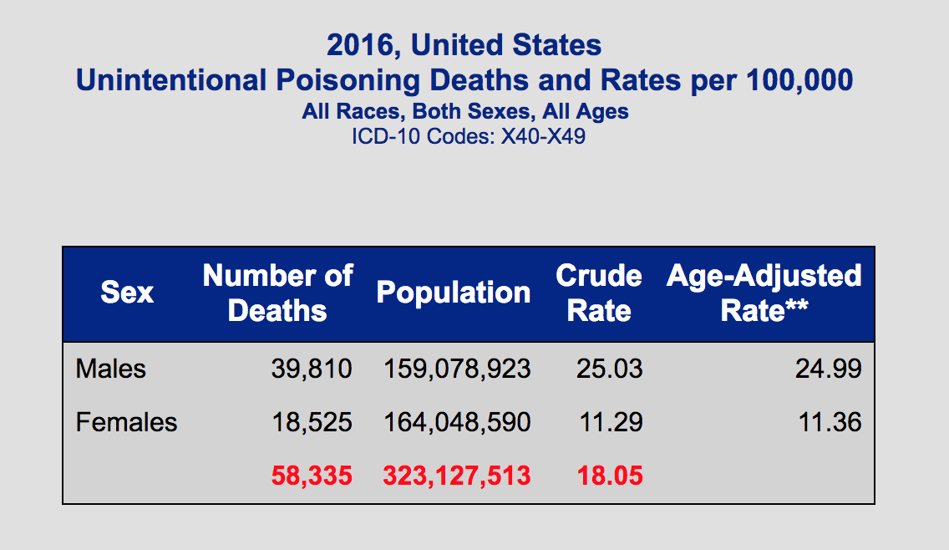

The images above screenshots of the data tables from WISQUARS representing information discussed regarding fatalities from poisonings.

Slide 4:

Public Health prevention of unintentional injuries from poisonings are focused more on children mainly from age 0 to 19. In 2016 855 child fatalities occurred from unintentional poisonings; this is equivalent to over 11 school buses filled with children (Centers for Disease Control and Prevention, 2017). One school bus at full capacity can hold 72 children, and 855 divided by 72 equals 11.875 therefore equating to over 11 school buses filled with children. Unintentional poisonings among children can happen every day in the home by children mistaking house cleaner for juice or medication for candy (Centers for Disease Control and Prevention, 2015). These injuries can happen across all demographics, but can also be prevented across each population.

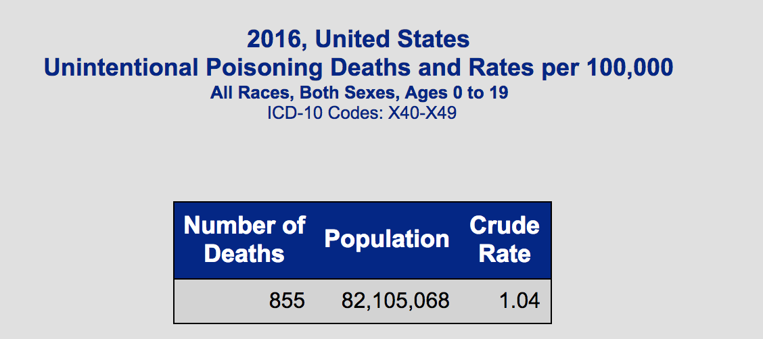

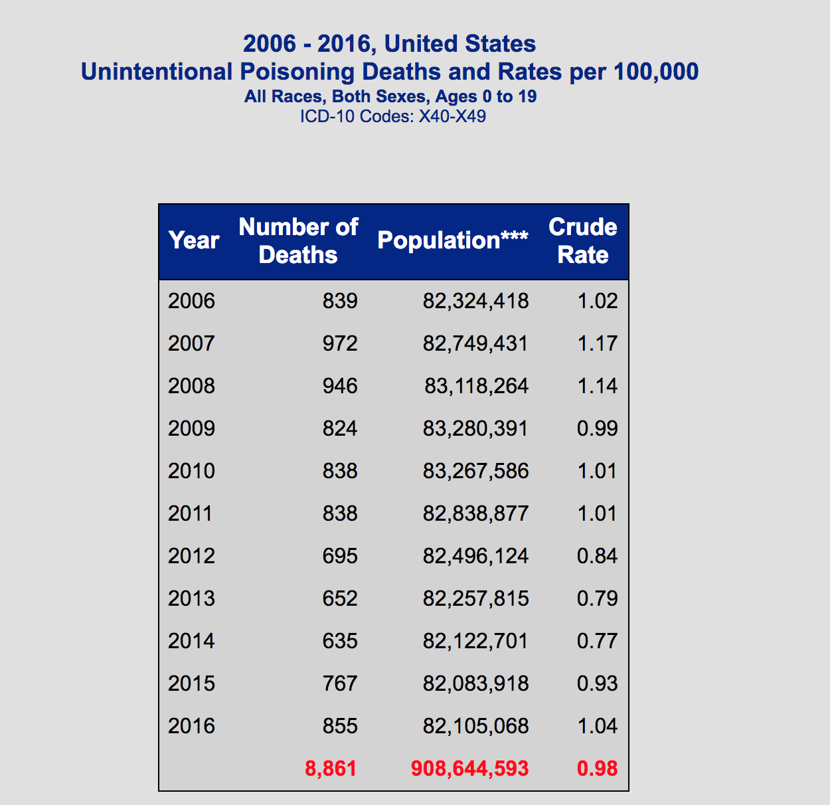

The images above are screenshots of the data tables from WISQUARS representing information discussed regarding fatalities from poisonings. Another images show the resemblance of household cleaner, which is a common causes of unintentional poisonings.

Slide 5:

In this slide we see the Haddon Matrix for risk factors associated with unintentional poisonings (American Association of Poison Control Centers, 2018; Centers for Disease Control and Prevention, 2015; Parachute, 2015). A few major factors include an individuals’ knowledge of poisonous substances and understanding of what to do when a poisoning occurs, the type of substance consumed or ingested, the accessibility to the poisonous substance in the physical environment, and the accessibility to medical and emergency services. This is not an exhaustive list of risk factors but are all essential aspects when considering prevention.

http://www.oninjuryresources.ca/downloads/training/About_Haddons_Matrix_FIPP_OIPRC.pdf

http://www.parachutecanada.org/injury-topics/topic/C16

https://www.cdc.gov/homeandrecreationalsafety/poisoning/preventiontips.htm

 | Person or Host | Agent | Physical Environment | Social Environment
Pre Event | Individuals’ skills and ability to open package and containers  Knowledge and understanding of potentially harmful substances  Individuals’ likeliness to take risks | Type of substances  Amount of substance  Recommended compared to dangerous amount for consumption | Storage of substances  Access to substances  Visible nature of substances  Unknown substances in environment due to outside sources  Disposal of substances in a proper and safe manner | Behaviors in household, work environment, and school around safety  Knowledge of safe containers and packages  Attitudes towards seeking medical care  Storage made by manufacturer
Event | Health of individual  Current medications taken by individual  Size of individual | Type of substance  Amount of substance consumed | Accessibility to poisoning center  Accessibility to Hospital Emergency Room  Knowledge of poisoning hotline  Knowledge of next steps  Length of time between poisoning and treatment | Ability to recognize poisoning has occurred  Knowledge of potentially poisoning substances  Assistance available in area poisoning occurred  Knowledge of actions necessary in emergency situations
Post Event | Health on individual  Current medications taken by individual  Size of individual  Amount of substance consumed | Absorption rate of substance | Distance to medical care (either poisoning center or emergency department)  Access to health insurance  Knowledge of medical staff  Relocation and improved storage of substances | Poisoning helpline  Education to children and parents regarding potentially poisonous substances, response in emergency situations, and prevention efforts  Public health awareness  Access to poisoning center or emergency department  Education for medical personnel

Slide 6:

Prevention of unintentional poisonings among children are a major focus within the National Action Plan for Child Injury Prevention, as it is one of main causes of child fatalities each year (Centers for Disease Control and Prevention, 2016b). Below are the recommended suggested prevention tools from the CDC, American College of Preventive Medicine, and National Safety Council (American College of Preventive Medicine, 2014; Centers for Disease Control and Prevention, 2016b; National Safety Council, 2018). Key recommendations include the ACPM Childhood Injury Risk Assessment Tool, which is used as a guide for individuals in the home or visiting a home to assess the risk of an injury occurring, the Up and Away Initiative developed by the CDC to keep medication out of sight and reach of children, and understanding the essential steps to take when a poisoning occurs which includes calling 911 and/or poison helpline, seek medical help and emergency services immediately.

Notes: Prevention efforts have been developed through the combination of data and surveillance, research, communication, education and training, health systems, policy, and public awareness (Centers for Disease Control and Prevention, 2016a).

Slide 7:

Prevention of unintentional injuries from poisonings among children age 0-19 is a necessity to improve the rate of childhood fatality and give more children the opportunity to make a difference for other individuals just as we hope to. Resolving the problem of poisonings from medications and household products requires primary, secondary, and tertiary prevention. Primary prevention requires education and awareness emphasized for parents, guardians, teachers, caretakers, and medical personnel regarding the risks, helpful tips, and essential steps in an emergency situation regarding unintentional poisonings among children; additionally including information on how to educate children about poisoning risks. (Committee on Poison Prevention and Control, 2004). Secondary prevention entails reducing the risk of serious injury or death in the event of an unintentional poisoning by increasing awareness of the Poison Control Hotline number. The American Associations of Poison Control Centers provide a 24/7 hotline providing free medical advice when poisonings occur. Awareness should be improved through advertisement and resources in schools, day care, health care provider locations, and social media (American Association of Poison Control Centers, 2018). Tertiary prevention is integral in solving the problem of unintentional childhood poisonings through improvements in policy regarding education and manufacturer packaging (Committee on Poison Prevention and Control, 2004). Policies should be put into place to ensure education on unintentional poisonings are made mandatory for parents, teachers, and caretakers. Child resistant packaging is the most effective way to assure children cannot access poisonous medications and household products, therefore it should be mandatory manufactures are required to do so with all products (Agency for Healthcare Research and Quality, 2014).

Slide 8:

Poisonings happen every day and unintentional poisonings result in the death of over 2 children per day. Unintentional injuries from poisonings can happen to anyone who mistakes cleaner for juice or medication as candy even our siblings, cousins, or children we babysit, but it can also be prevented. Increasing awareness of the issue, improving education, and providing the resources to help others prevent their child from being next is essential to securing the safety of the future generation of children.

This completes the presentation on poisoning prevention, thank you.

Annotated Bibliography:

Agency for Healthcare Research and Quality. (2014). The guide to clinical preventive services. Retrieved from: https://www.ahrq.gov/sites/default/files/publications/files/cpsguide.pdf

This online guide, created by a government website, provides recommendations based on a number of health topics and populations including children and injury prevention.

American Association of Poison Control Centers. (2018). Prevention and Education. Retrieved from: https://aapcc.org/Prevention.

This website is created by a non-profit organization responsible for all poison control centers, hotline, and information for the United States.

American College of Preventive Medicine. (2014). ACPM childhood injury risk assessment tool project. Retrieved from: https://www.acpm.org/page/ChildInjuryRisk?

This website provides information from a professional medical society regarding preventive medicine; childhood injury prevention is included within their extensive research.

Committee on Poison Prevention and Control. (2004). 8. Prevention and public education. Forging a poison prevention and control system. Retrieved from: https://www.ncbi.nlm.nih.gov/books/NBK215795/pdf/Bookshelf_NBK215795.pdf.

This online book consists of extensive information on all necessary components of prevention of poisoning, including education; the book was created by multiple private, non-profit national organizations.

National Safety Council. (2018). Prevent poisoning and drug overdose. Retrieved from: https://www.nsc.org/home-safety/safety-topics/other-poisons/lead

This website is created through a national non-profit organization that provides information on safety and prevention on topics including poisonings.

Parachute. (2015). Poisoning prevention. Retrieved from: http://www.parachutecanada.org/injury-topics/topic/C16

This website was created by a non-profit organization from Canada that provides information, programs, and resources on the topic of poisoning prevention, additionally specifically for children.

Bibliography:

Agency for Healthcare Research and Quality. (2014). The guide to clinical preventive services Retrieved from https://www.ahrq.gov/sites/default/files/publications/files/cpsguide.pdf
American Association of Poison Control Centers. (2018). Prevention and Education Retrieved from
https://aapcc.org/Prevention

American College of Preventive Medicine. (2014). ACPM childhood injury risk assessment tool project Retrieved from https://www.acpm.org/page/ChildInjuryRisk?
Centers for Disease Control and Prevention. (2015). Tips to prevent poisonings. Recreational and home safety: Poisonings Retrieved from https://www.cdc.gov/homeandrecreationalsafety/poisoning/preventiontips.htm
Centers for Disease Control and Prevention. (2016a). A national action plan for child injury prevention Retrieved from https://www.cdc.gov/safechild/pdf/nap_poison_2013.pdf
Centers for Disease Control and Prevention. (2016b). National plan for child injury prevention Child safety and injury prevention. Retrieved from https://www.cdc.gov/safechild/nap/index.html
Centers for Disease Control and Prevention. (2017). WISQARS: Web-based injury statistics query and reporting system https://webappa.cdc.gov/sasweb/ncipc/mortrate.html
Committee on Poison Prevention and Control. (2004). 8. Prevention and public education Forging a poison prevention and control system Retrieved from https://www.ncbi.nlm.nih.gov/books/NBK215795/pdf/Bookshelf_NBK215795.pdf.
National Safety Council. (2018). Prevent poisoning and drug overdose Retrieved from https://www.nsc.org/home-safety/safety-topics/other-poisons/lead
Parachute. (2015). Poisoning prevention Retrieved from http://www.parachutecanada.org/injury-topics/topic/C16

