**Title**

Case Study: Analyzing 2007-2014 Supply Chains to Evaluate Athens-Clarke County’s Public/Private Recycling Program

**Author**

Spencer Tomlinson

College of Agriculture and Environmental Sciences

University of Georgia

446 Reese Street, Athens GA 30601

Email: wst51868@uga.edu

**Abstract**

This case study examines the advantages and limitations to the public-private partnership (PPP) recycling program as it operates in Athens-Clarke County and surrounding communities. This was achieved by combining a 2007-2014 time-series analysis of hub-network maps illustrating the recycling center’s supply chains with historical knowledge of the facility deduced from an informal interview with the recycling division’s lead Educational Program Specialist. The trend toward increased percent tonnage delivered from nearby municipalities suggests that a PPP recycling structure may be well-suited in rural Georgian counties that lack the resources to institute and sustain individual programs.

**Keywords**

Public-private incentive scheme, Athens-Clarke County recycling, time-series supply chain**Introduction**

As humanity becomes more aware of the global consequences of its own waste production, it is critical for policy-makers to formulate cost-effective waste management techniques that mitigate these negative externalities. In 2014, the Environmental Protection Agency (EPA) reported that Americans alone produced 258.5 million tons of municipal solid waste (United States, 2016). Recycling is one method to decrease contribution to the waste stream by re-processing and reusing materials recovered after consumption. Variability among the factors affecting the collection cost, recovered material prices, and alternative disposal options for recycling facilities across space has led to a great deal of variability in the tactics municipalities use when instituting their own recycling programs. The CEO of Waste Management, David Steiner, calls for revising recycling business models in a way that encourages stability in the face of weak market trends and low material prices (Steiner, 2016). The strategy of Athens-Clarke County (ACC) is a public-private partnership (PPP) between the county and Republic Services, a private recycling and waste disposal firm.

A well-organized partnership intends to capitalize on the differences in economic behavior between public and private sectors by assigning roles to the entity that is best equipped to manage the risks associated with each role. Here, the ACC Recycling Division’s partnership incentivizes Republic Services to operate Athens’ single stream recycling facility while leaving the collection processes up to public or private entities who benefit from depositing at the material recovery facility (MRF). In the year 2015, the US Department of the Treasury noted that PPP “…incentive structures have the potential to… improve the odds of a project’s long-term success.” (United States, 2015)

For the case of Athens, instituting price floors for the recycled materials sold by the facility and covering property costs for the facility operation firm allows the local government to increase the likelihood that a firm will be willing to supply recycling operations to meet political demands for waste management. In short, the partnership raises the net present value of investment into the supply of operational services for the MRF by lowering the risk of encountering unfavorable material prices, raising the price of the landfill tipping fee relative to the recycling fee, guaranteeing a minimal revenue stream, and lowering initial investment costs. The advantages and disadvantages of this form of recycling partnership in Athens can be identified by observing how supply changes over time in tandem with the promotional objectives and achievements of the ACC Recycling Division. As our global waste stream increases, such information is increasingly relevant for policy-makers looking to update or initiate a recycling program in their local community.

**Literature Review**

A common thread runs through the previous research comparing different recycling programs; evaluative recycling literature tends to place an emphasis on variations between regions’ waste collection techniques. Municipalities are seen as external facilitators of recycling performance by providing incentives to curb consumer behaviors. Jim Glenn’s analysis of historical US recycling trends identifies collection as the most costliest part of most recycling programs and proceeds to outline the universal frameworks and potentials for increasing recycling program efficiency through “fine tuning” collection techniques to meet the local recycling demand (Glenn, 1992). By highlighting the fact that recycling programs with the lowest cost per ton also tend to have the highest amount of material collected per container, the need for community participation through means of education or economic incentive are established. A 13-year panel study regressing 351 Massachusetts recycling program rates with 14 social, economic, and geographical variables found two factors that increased program efficiency consistently across spatial differences: access to a MRF and a “pay as you throw” (PAYT) trash disposal disincentive (Starr and Nicholson, 2015). Other collection scheme variables, such curbside recycling service, represent consistent weaker correlation with program efficiency unless combined with other specific program specifications. This study demonstrates PAYT and access to an MRF consistently increase recycling program efficiency while most factors, such as education efforts and drop-off collection systems, can increase program performance when applied to particular regions. These studies highlight the need for variation in recycling collection and community participation techniques to meet diverse recycling demands.

Two studies have employed survey methods to determine the strongest motivators for recycling participation. One found intrinsic motivation to be the most powerful motivator over social expectation and economic incentive. (W. Kip, et al., 2011). The other found monetary benefit, impact awareness, and the opportunity to participate to be the strongest recycling motivators (Abbasi and Sheikh, 2016). This is promising, because it means the public sector has an opportunity to boost recycling performance both directly by passing laws that incentivize citizens to recycle as well as indirectly by demonstrating the benefits of recycling to the participants.

Despite the surplus of research regarding recycling incentive variables influencing program efficiency at the individual level, there is a lack of literature that investigates state or federal incentives. An 11-year panel study covering 223 Ontario municipalities whose waste management funding was dependent on their recycling rate performance found no statistically significant relationship between program funding and program performance. This is most likely explained by a disconnect between waste management demands and future funding predictions (Lakhan, 2016). In this way, Ontario was encouraging its municipalities to profit-maximize with respect to their recycling program structures which is not effective in increasing recycling performance.

The Athens MRF operates via a single-stream system that does not require paper to be separated from glass, metals, and plastics upon arrival. In 2015, a study encompassing 25 Central Florida communities found that households in communities implementing single-stream recycling programs produced 0.98 kg of recyclables per day while dual stream households produced 0.38kg of recyclables per day (Maimoun, et al., 2016). This evidence suggests that access to a single-stream facility like the one in Athens increases collection efficiency due to an increase in materials collected per household.

**Objectives**

The main focus of this study is to analyze the material supply chain for the Athens MRF from nearby public and private entities over the 2007-2014 time period. In addition, this study aims to provide insight on the advantages and disadvantages of Athens’s PPP recycling program as it relates to the city’s and surrounding counties’ recycling demands. Finally , this study aims to identify regions in Georgia that could potentially benefit from the introduction of a PPP recycling program.

**Data Sources**

An informal interview was conducted with Mason Towe, the county Recycling Division’s lead Education Program Specialist. Towe provided details regarding the revenue streams between haulers, past and present private facility operators, the recycling division, and the encompassing Athens Solid Waste Department. He also provided historical information regarding the (MRF) and its operators.

In addition to knowledge of the logistical structure of the partnership’s incentivization and funding schemes, the Recycling Division also supplied fiscal reports for years 2007-2014. Specifically, the reports supplied annual tonnage of each county or company delivered to the MRF as well as annual income/expense summaries.

**Methods**

The county’s recycling fiscal report data was graphically displayed into a time-series of hub network maps encompassing Athens and its surrounding counties. Graphical representations are directly proportional to the tonnage supplied by each entity that year. Each year’s map was compared to identify general trends in the MRF supply chain. Observed supply trends were compared with historical information pertaining to the Athens MRF. Finally, the advantages and disadvantages of the PPP recycling program were considered to identify regions within Georgia that could benefit from a similar model. Georgian counties with high expectations for population growth that currently possess weak infrastructure for recycling were targeted.

**Results and Discussion**

Analysis of the network hub maps in tandem with a background for the MRF’s recent history revealed that the Athens MRF possessed the ability to adapt its business model to local market trends in order to maintain the growth of its yearly performance rates. Figure 1 illustrates stagnant program growth from 2008-2011, as total tonnage delivered barely fell by 0.6% over a four-year period. This was followed by comparatively explosive growth of 44.5% over the next three years until 2014.  Converting the facility from a dual-stream to a single-stream recycling center in October of 2011 was done in response to Gwinnett County’s 2009 switch to a single stream recycling facility (Towe, 2018). The conversion was also done at the same time as the facility’s private operator changed ownership from FCR Incorporated to ReCommunity. In this case, the PPP agreement allowed for the facility to change hands from a company unequipped to handle the investment of redesigning a recycling facility to one with the means to do so in a way that increased total tonnage delivery and thus waste stream diversion.

**Athens Public-Private Recycling Hub Network Maps**

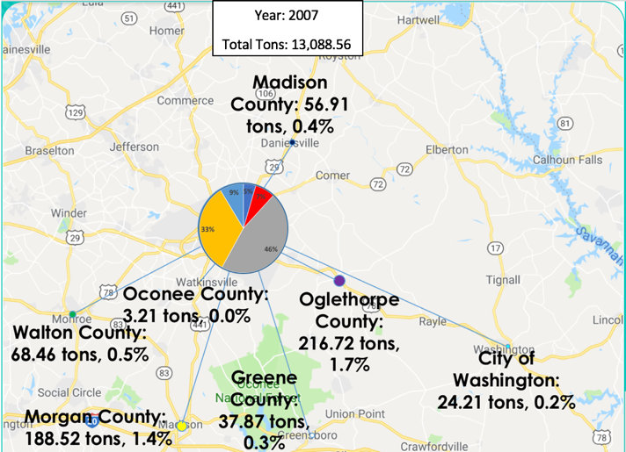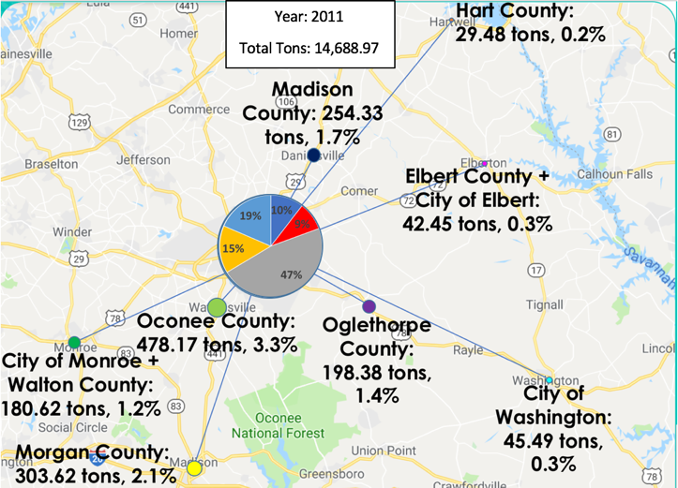

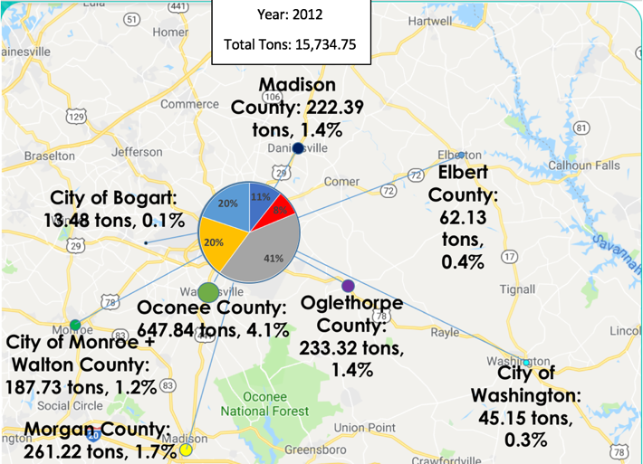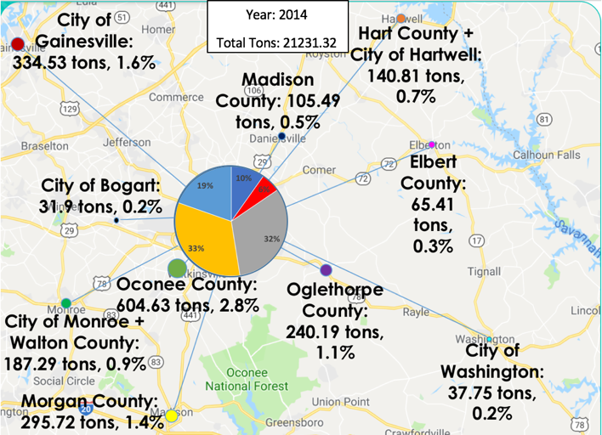

Figure 1: Local municipal recycling suppliers to the Athens MRF are represented by dots with areas proportional to the tonnage supplied. Total tons represents the total tonnage of recyclable materials delivered to the MRF that year. The area of the pie chart represents the year’s total tonnage delivered to the MRF by local municipalities (dark blue), UGA (red), private haulers (orange), ACC haulers (grey), and miscellaneous drop-offs (light blue). Counties and cities located within one another are represented by the same data point.

Other trends observed after the installation of the single stream modifications in 2011 were a doubling of the percentage of recyclables supplied to the MRF by neighboring municipalities (from 5% to 10%) and a 10% decrease in the overall tonnage supplied by ACC haulers collecting from the downtown area. This behavior suggests that by adjusting for competitors, the Athens MRF is becoming an increasingly attractive destination for the recyclables of nearby municipalities more so than it is relative to the tonnage delivered by ACC. This is good news for Athens, because it has to pay tipping fees on ACC’s recyclables delivered but it receives 80% of the revenue from the sale of the recyclable materials. In addition, the program is successfully encouraging widespread participation from communities without extensive recycling programs. If there is less percent tonnage coming from ACC haulers and more coming from other sources, the higher the Recycling Division’s annual net profit will be for that year.

However, it is also crucial to examine how the Athens Solid Waste Department manages the recycling program’s funding. The annual net profit for the Recycling Division is artificially inflated by an inner-department Athens Solid Waste funds transfer from the county landfill program. The county’s return on the investment of the landfill is the mechanism through which the taxpayer is still indirectly on the hook for the recycling operator’s subsidies. A lower percentage of tonnage coming from non-ACC haulers, the less funding that must be transferred from the landfill to the recycling division. While the PPP recycling program in Athens was praised for disincentivizing landfill use through an artificially inflated tipping fee ($46/ton), it is equally important to remember that the recycling program added risk to the roughly $3.7 million landfill addition the county invested in 2010 (Towe, 2018).

Based on the supply chain maps’ trend displaying growing widespread participation from local municipalities, counties likely to experience success from implementing their own PPP recycling program are those surrounded by less developed counties. Many southern Georgia citizens with a low tax base, a low-density population, and a low level of commercial development don’t have access to a dependable recycling service due to the high cost of developing a program and little guarantee that enough recyclables will be supplied. A PPP recycling program that promotes widespread participation offers the investing county a way to share the cost of operating the program with nearby municipalities that can’t bear the cost of their own program. Based on this information, Lowndes County encompassing Valdosta, Georgia and bordering the state of Florida has the potential to benefit itself and the surrounding region the most from a PPP recycling program.

**Limitations & Future Pathways**

For this study the advantages and disadvantages of the PPP program were only identified as they pertain to Athens. To gain a deeper understanding of the universal advantages and limitations of a public-private recycling partnership outside of Athens, panel data must be collected to include more PPP and publicly owned recycling operations than the Athens MRF alone. Results could provide lawmakers in other states experiencing different socioeconomic influences on their recycling program with a more reliable framework to see if a PPP recycling program might work for them.

**Acknowledgement**

Special thanks to Mason Towe and the Athens-Clarke County Recycling Division for taking the time to conduct an interview, providing the data, and granting a tour of the facility!

**References**

Abbasi, Muhammad Nauman and Nadeem Ahmad Sheikh. “Attitudes and Motivations Towards Plastics Recycling: A Multi-Tier Supply Chain Approach.” *Pakistan Journal of Social Sciences (PJSS),* vol. 36, no. 2, July 2016, pp. 705-722. Web. 24 Apr. 2018.

Glenn, Jim. “Efficiencies and Economics of Curbside Recycling.” *Biocycle,* no. 7, 1992, p.30.

Lakhan, Calvin. “The Relationship between Municipal Waste Diversion Incentivization and Recycling System Performance.” *Resources, Conservation & Recycling,* vol. 106, 01 Jan. 2016, pp.68-77. Web. 24 Apr. 2018.

Maimoun, Mousa A., et al. “An Environmental-Economic Assessment of Residential Curbside Collection Programs in Central Florida.” *Waste Management*, vol.54, 01 Aug. 2016, pp.27-38. Web. 24 Apr. 2018.

Starr, Jared and Craig Nicolson. “Patterns in Trash: Factors Driving Municipal Recycling in Massachusetts.” *Resources, Conservation & Recycling,* vol. 99, 01 June 2015, pp. 7-18. Web. 24 Apr. 2018.

Steiner, David. 2016. “Resource Recycling Conference: Remarks as Delivered by David Steiner, CEO, Waste Management.” *Resource Recycling Conference*. Speech, August 31.

Towe, Mason. Personal Interview. 01 Mar. 2018.

United States. Department of the Treasury. Office of Economic Policy. *Expanding the Market for Infrastructure: Public-Private Partnerships*. Washington: Government Printing Office, 2015. *Treasury.gov.* Web. 10 Mar. 2018.

United States. Environmental Protection Agency. *Advancing Sustainable Materials Management: 2014 Fact Sheet.* Washington: Government Printing Office, 2006. *EPA.gov.* Web. 24 Apr. 2018.

W. Kip, Viscusi, et al. “Promoting Recycling: Private Values, Social Norms, and Economic Incentives.” *The American Economic Review*, no. 3, 2011, p. 65. Web. 24 Apr. 2018.